# What is a Virtual Environment?

Python's official documentation says:

"A virtual environment is a Python environment such that the Python interpreter, libraries and scripts installed into it are isolated from those installed in other virtual environments, and (by default) any libraries installed in a “system” Python, i.e., one which is installed as part of your operating system"

To use venv in your project, in your terminal, create a new project folder, cd to the project folder in your terminal, and run the following command:

**python<version> -m venv <virtual-environment-name>**

**C:/Users/SaifUllahKhan/AppData/Local/Microsoft/WindowsApps/python3.9.exe -m venv venv**

**python3.8 -m venv env : -** create the virtual env folder with the env

**.\venv\Scripts\activate : -** Used to activate the virtual env

pip freeze > requirements.txt

~ pip install -r requirements.txt

# Import File

Import <file name > :- when we import the file we the file will automatically run.

**Pydantic** is the most widely used data validation library for Python.

# How to run a file containing Fast api as staring point :-

**if __name__ == "__main__":  
   uvicorn.run("FastApi:app", host="127.0.0.1", port=8000, reload=True)**

then just write this in terminal

**python.exe .\FastApi.py**

**fastapi dev <python-file_name> :-**  its like that **fastapi dev .\FastApi.py**

The upper link open the simple website and its entry point but if I go with the /doc then i get the swagger view

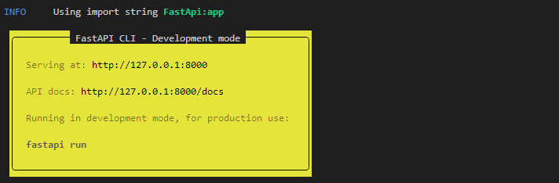

**uvicorn FastApi:app –reload :-**  this command also use to run the command but it will generate only website link not the swagger link but if I want to get I just add

“**/doc ”** to that link <http://127.0.0.1:8000> so the link will be like

[**http://127.0.0.1:8000/docs**](http://127.0.0.1:8000/docs)

